Crash dump collection process (TWCSSSpooler)

# Install

Install [Debug Diagnostic Tool v2.0 tool](http://www.microsoft.com/en-in/download/details.aspx?id=40336). Download

URL: <http://www.microsoft.com/en-in/download/details.aspx?id=40336>

# Configure DebugDiag 2.0 Collection

Open the tool and click the Add Rule button and create a new Crash rule.

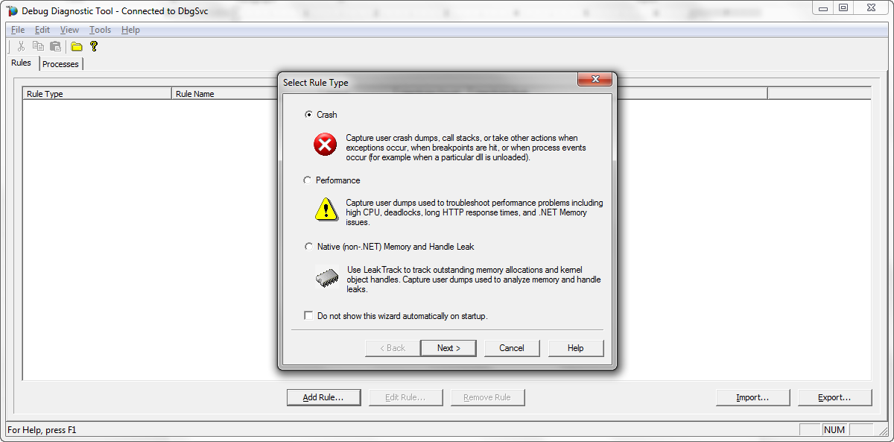

Next, select the target type. In our case specific process

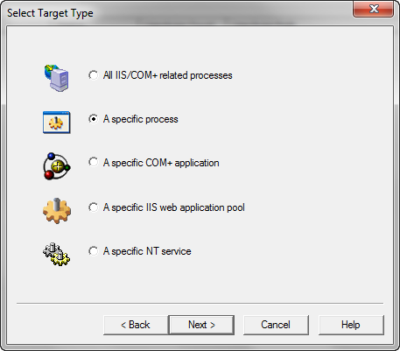

We need to collect crash dumps of “TWCSSpooler” process. So we choose that one.

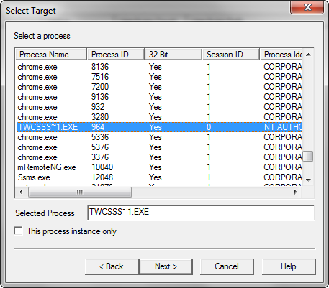

Keep default values

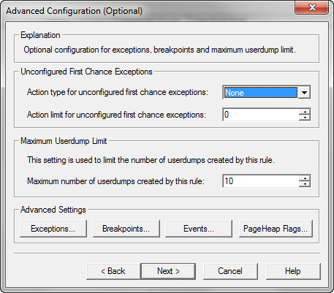

The next window allows you to name the rule and to configure the location where the userdump file is created.

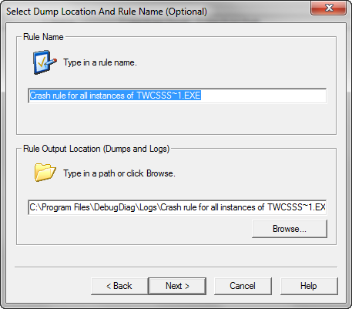

The last window asks you if you want to activate the rule.

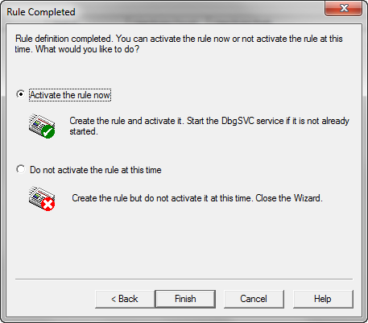

Once we configure the rule, you can see the rule and the number of userdumps that have been generated by the rule.

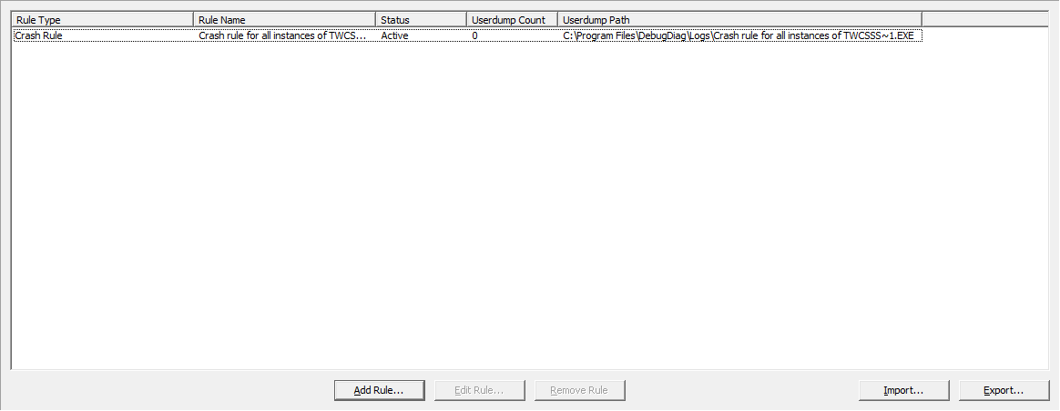

# Finally

DebugDiag runs as background service. It will collect maximum of 10dumps by default. Upload all the dumps to Allscripts FTP folder

Path: [ftp://intallsupport.allscripts.com/Upload/Abhishek/DebugLogs/CrashDumps/<ClientName](ftp://intallsupport.allscripts.com/Upload/Abhishek/DebugLogs/CrashDumps/%3cClientName)>

Also upload PDB file of TWCSSpooler process which can be found under (Allscripts Healthcare Solutions\Touchworks Web\Touchworks Print Center) folder

File Name: TWCSSSpooler.pdb